**NANDAN ELECTRICALS**

Class Govt. Licensed Electrical Contractors

**Kullunde, Halaga – 577220**

Shimoga Dist

L No: Date: _______

===========WIRING DIAGRAM OF LIGHTING /AEH / POWER / IP INSTALLATION============

at______________________of Sri__________________________________________________

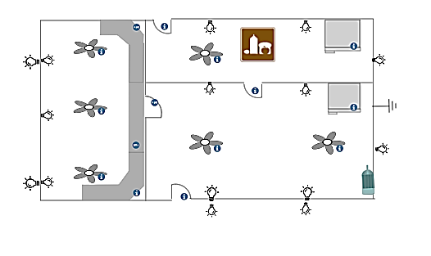

|  |  |
| --- | --- |
| **Sl.**  **No** | ***INDEX*** |
|  | Pilot Lamps  Cutouts  Switches  Neutral Link  Motor  Earth  Meter Board  Lights |

|  |  |
| --- | --- |
| **Sl.**  **No** | ***Index*** |
| 1  2  3  4  5  6  7  8  9 | Drop Light  Bracket Light  Water Tight  Bulk Head  Main Switch  Wall plug 5A  Wall plug 15A  Meter Board  Earth |

Consumer Contractor